**Emergency Wait Time Predictor — City-wide**

**Team Name :**  
**Team Members:**

Sathvik(2420030685)

Prashamsa(2420030692)

Sharanya(2420030747)

**1. Problem / Opportunity Domain**

**Domain of Interest:**  
 The project focuses on predicting emergency room (ER) and emergency department (ED) wait times across an entire city by leveraging historical data, live telemetry, and advanced demand prediction models. It aims to provide real-time and short-term forecasts of key metrics such as hospital wait times, triage levels, and ambulance arrival windows. This enables patients, emergency medical services (EMS), and hospital administrators to make faster, data-driven decisions for improved care delivery and resource management.

**Description:**  
 The **Emergency Wait Time Predictor** is an intelligent system that ingests a wide range of data sources, including historical ED arrivals, triage categories, staffing rosters, ambulance dispatch records, public events, weather conditions, and real-time hospital occupancy levels. Using time-series forecasting, queueing models, and machine learning features (such as seasonality trends, event/holiday patterns, weather, and traffic), it generates accurate predictions of wait times—covering metrics like time-to-triage, time-to-physician, and expected boarding duration—for every hospital and aggregated city zones. The system also provides confidence-scored predictions along with recommended actions, such as redirecting patients to less crowded facilities or triggering surge capacity to handle spikes in demand.

**Why Chosen:**  
 Long ED waits can lead to patient distress, delayed treatment for time-sensitive conditions, ambulance backlogs, and overall inefficiency in the healthcare system. By offering actionable forecasts, this predictive tool can help reduce inequities in access to emergency care, improve resource allocation, and enhance the patient experience. It supports smarter urban health planning, ensuring that hospitals and emergency responders are better prepared to manage surges, minimize delays, and ultimately save lives.

**2. Problem / Opportunity Statement**

**Problem Statement:**  
City hospitals face unpredictable surges and uneven load leading to long, poorly communicated wait times. Patients lack transparent guidance on where to seek timely care; ambulances experience delays due to ED crowding. Manual resource adjustments are reactive and slow. We need a city-wide predictive system that gives accurate, real-time wait time forecasts (and actionable recommendations) to patients, EMS, and administrators.

**Problem Description (Expanded):**

Emergency department (ED) flow is highly dynamic, influenced by unpredictable patient arrivals, staffing levels, inpatient bed availability, and external factors such as mass gatherings, weather changes, and traffic conditions. While current hospital dashboards typically display only the present queue lengths or occupancy status, they rarely provide short-term forecasts of wait times or recommend proactive mitigations. As a result, hospitals often face ambulance diversions, patient boarding, and overcrowding, which contribute to delayed treatments, suboptimal care, and poor patient satisfaction. This project aims to address these challenges by predicting ED wait times in real time, enabling faster decision-making to reduce avoidable delays, inform patient choices, and help hospitals proactively manage surge capacity and staffing.

**Context:**

Urban health systems consist of multiple emergency care access points, including public and private hospitals, each operating within its own data ecosystem. Although valuable information—such as hospital electronic health records (EHRs), ambulance dispatch logs, traffic patterns, and weather data—already exists, it is often siloed and underutilized. By integrating these diverse data sources into a unified, city-wide forecasting platform, the project seeks to support equitable access to emergency care and enhance operational decision-making. Collaboration with hospitals, emergency medical services (EMS), and municipal health authorities will be key to ensuring accurate data sharing, robust forecasting, and effective implementation across the healthcare network.

Here’s an additional **point under each heading or key phrase** to expand the details:

### **Alternatives**

* **Static published wait times (inaccurate, stale):** Often fail to account for sudden surges, leaving patients with misleading information.
* **Phone hotlines for wait time queries (manual, limited coverage):** Depend on staff availability, causing delays in updates and inconsistent accuracy.
* **Single-hospital internal prediction (doesn’t support city routing):** Cannot optimize ambulance routing or patient decisions across multiple facilities.

### **Customers / Users**

* **Patients & caregivers (public-facing wait time app/website):** Gain the ability to choose facilities based on real-time forecasts, reducing unnecessary travel.
* **Ambulance/EMS dispatch centers (dynamic routing):** Can prioritize hospitals with lower predicted waits, improving emergency response efficiency.
* **Hospital admins & bed managers (capacity planning):** Receive early warnings to deploy surge staffing or open additional beds before overcrowding occurs.
* **Public health / city health departments (system oversight):** Use aggregated data to track city-wide ED performance and identify underserved areas.
* **Policy makers & insurers (policy & incentive design):** Can design reimbursement models or incentives to reward efficient patient flow and reduced wait times.

### **Emotional Impact**

* **Relief when accurate wait estimates reduce anxiety:** Patients and families feel more in control of care decisions.
* **Frustration decreased for families making care decisions:** Reduces confusion about which facility to visit, especially in emergencies.
* **Reduced moral distress for staff seeing improved flow:** Improves staff morale by easing the pressure of overcrowded EDs.

### **Quantifiable Impact Goals**

* **Reduce average ED wait time by X% (target: 15–25% within 12 months):** Leads to faster treatment for critical conditions and better overall outcomes.
* **Reduce ambulance diversion events by Y% (target: 30%):** Ensures patients are taken to the right facility on the first attempt, saving time and resources.
* **Improve on-time arrivals to appropriate facilities:** Minimizes delays for high-acuity patients needing specialized care.
* **Increase patient satisfaction scores by Z points:** Demonstrates tangible improvements in patient experience and trust in emergency services.

**3. Addressing SDGs**

**Relevant SDGs:**

Here’s an additional point under each SDG:

* **SDG 3 – Good Health and Well-being:** Enables faster diagnosis and treatment through real-time health monitoring and communication.
* **SDG 9 – Industry, Innovation and Infrastructure:** Promotes the development of smart ambulance networks and AI-driven dispatch systems.
* **SDG 10 – Reduced Inequalities:** Ensures affordable emergency services for underserved and rural populations.
* **SDG 11 – Sustainable Cities and Communities:** Integrates emergency health services into smart city planning for efficient disaster response.

**How Addressed:**

The system tackles these challenges by **predicting emergency department wait times** and **recommending patient or ambulance redistributions** across hospitals. By offering real-time forecasts and actionable insights, it helps ensure **timely emergency care**, minimizes the **risks of overcrowding**, and promotes **equitable access to services across all neighborhoods**, allowing hospitals and EMS to respond proactively rather than reactively.

**4. Stakeholders**

### **Primary Stakeholders**

* **Patients & caregivers:** Directly benefit from accurate wait time forecasts that reduce anxiety and improve decision-making during emergencies.
* **EMS / Ambulance services:** Use real-time predictions to route patients to hospitals with the shortest expected waits, improving response efficiency.
* **ED clinicians, triage nurses, bed managers:** Gain actionable insights to prioritize critical cases and optimize staffing for incoming surges.
* **Hospital operations leaders:** Leverage forecasts to plan capacity, allocate resources, and prevent bottlenecks.
* **City health department / municipal authorities:** Monitor system-wide performance to ensure equitable access and guide emergency response planning.

### **Secondary Stakeholders**

* **Primary care/urgent care centers (as alternative sites):** Benefit from redirection of non-critical patients, reducing ED congestion.
* **IT vendors / EHR providers:** Support system integration and data exchange for accurate, real-time predictions.
* **Insurers / payers:** Use analytics to design incentives for hospitals that improve flow and reduce costly delays.
* **Event organizers (for surge planning):** Collaborate to anticipate ED demand during large gatherings or public events.

**5. Power–Interest Matrix (summary)**

* **High interest / High power:** City Health Department, Large Public Hospitals, EMS Leadership.
* **High interest / Low power:** Patients, Local clinics, Community groups.
* **Low interest / High power:** Insurers, regulatory bodies.
* **Low interest / Low power:** Some small private clinics.

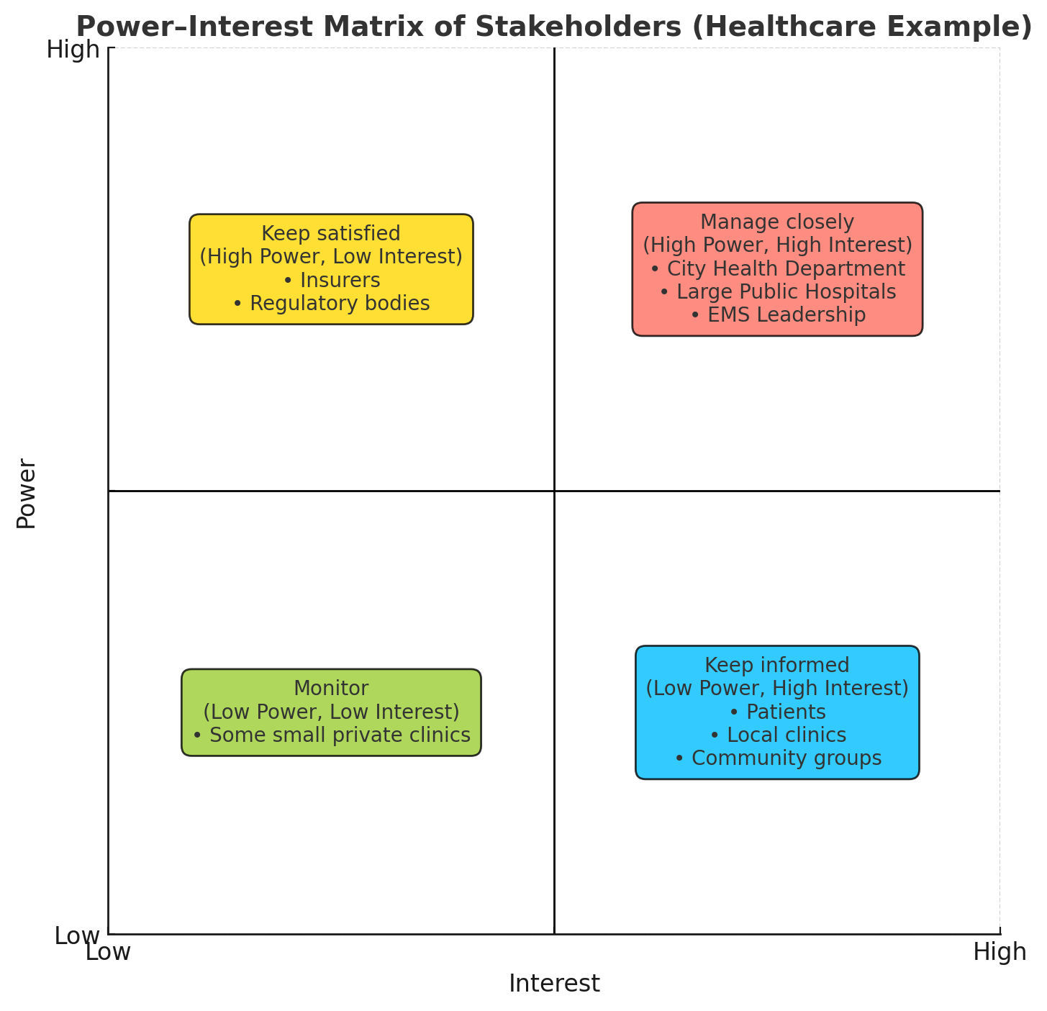

**6. Empathetic Interviews (plan + sample questions)**

|  |  |  |
| --- | --- | --- |
| **I need to know (thoughts, feelings, actions)** | **Questions I will ask (open questions)** | **Insights I hope to gain** |
| How do patients currently choose which ED to visit? | “Can you walk me through the last time you had to choose an ED?” | Understand patient decision factors, priorities, and pain points. |
| How does EMS decide hospital destination? | “How do ambulance crews choose hospitals right now?” | Learn the decision rules and constraints EMS uses. |
| What are staff pain points during surges? | “Can you walk me through the last time your ED got unexpectedly busy?” | Identify operational bottlenecks, workflow challenges, and stress points. |
| What data is available and who controls it? | “What data can your EHR share in real time?” | Understand access limitations, data ownership, and interoperability issues. |
| What information would help staff make better decisions? | “What information would have helped you make a different decision?” | Discover unmet information needs and desired decision-support tools. |
| What are patient expectations for hospital wait times and recommendations? | “What would help you decide which hospital to go to if you were unwell?” | Understand the type of information patients trust and prefer. |
| How do EMS and hospital staff perceive algorithmic recommendations? | “How comfortable would you be using a tool that suggests which ED to go to?” | Identify trust concerns, usability expectations, and barriers to adoption. |
| How should notifications or dashboards be presented? | “What’s the easiest way for you to receive alerts or updates?” | Inform UI design, notification channels, and actionable insights. |

**7. Persona(s)**

**Persona 1 — Riya, 32, caregiver**

* Lives in suburban zone; anxious when needing urgent care for child; lacks medical knowledge.
* Needs: quick, trustworthy wait estimate and guidance on nearest suitable facility.

**Persona 2 — Vinod, 45, EMS dispatcher**

* Manages ambulance assignments during peak hours.
* Needs: accurate short-term forecasts and system recommendations integrated into dispatch console.

**Persona 3 — Dr. Kumar, ED Medical Director**

* Responsible for throughput and clinician workload.
* Needs: predictive alerts to trigger surge staffing or divert policies.

**8. Common Themes, Behaviors, Needs, Pain Points**

**Common Themes:** need for short-term forecasting, data sharing challenges, trust & transparency, and the need for actionable recommendations.

**Common Behaviors:** choosing nearest ED by familiarity rather than current load; EMS sometimes bypasses due to perceived crowding.

**Needs:** real-time accuracy, clear explanations (why a hospital is predicted busy), multi-channel delivery (app, SMS, EMS console).

**Pain Points:** siloed hospital systems, privacy/compliance concerns, risk of misinformation if predictions are wrong.

**9. POV Statements & HMW Questions**

**POV:** Patients need a trustworthy, easy way to know where they’ll be seen quickly because current wait times are unpredictable and stressful.

**HMW examples:**

* How might we provide accurate 15–60 minute ED wait forecasts to patients and EMS?
* How might we integrate forecasts into EMS dispatch workflows smoothly?
* How might we present prediction uncertainty so users trust recommendations?

**10. Ideation — Solution Concepts**

**Idea 1 — Real-time Wait Predictor & Public App**

* Public-facing app/website showing predicted wait times, travel time, and confidence interval.
* Includes triage guidance: “If chest pain — call 108/911.”

**Idea 2 — EMS Integration & Dynamic Routing**

* API feed to dispatch consoles with predicted acceptance times and suggested destinations.

**Idea 3 — Hospital Operations Dashboard**

* Predictive alerts for administrators (expected crowding in next 30–120 minutes) plus suggested mitigations (call in staff, open fast-track).

**Idea 4 — City Surge Management**

* City dashboard aggregates forecasts to coordinate transfers, temporary field units during major events.

**Idea 5 — Patient Triage Assistant (Chatbot)**

* Chatbot helps users decide whether ED, urgent care, or teleconsult is appropriate based on symptoms.

**11. Solution Concept Form — Emergency Wait Time Predictor**

**1. Problem Statement:**  
Reactive ED management causes long waits, inequitable access, and inefficient ambulance routing — we need proactive, city-wide wait forecasting.

**2. Target Audience:**  
Patients, EMS, hospital operation teams, city health authorities.

**3. Solution Overview:**  
A predictive platform combining historical ED flow, current occupancy, EMS dispatch data, traffic and weather feeds to produce short-term wait predictions and actionable recommendations via app, APIs, and dashboards.

**4. Key Features:**

* City map with hospital tiles and predicted wait metrics (time-to-triage, time-to-physician).
* Confidence scores & explanation (e.g., “High incoming ambulance load predicted due to event”).
* EMS API for dynamic routing.
* Admin console for surge alerts and staff scheduling suggestions.
* Patient triage wizard and directions to nearest recommended facility.

**5. Benefits:**

* Faster access to care and reduced unnecessary ED visits.
* Better ambulance turnaround times.
* Data-driven surge preparations and improved staff utilization.

**6. Unique Value Proposition (UVP):**  
City-wide forecasting that routes patients and EMS in near real-time using transparent models and actionable recommendations.

**7. Key Metrics:**

* Forecast accuracy (MAE of wait time predictions).
* Reduction in average wait time.
* Number of diverted/redirected patients successfully routed.
* EMS turnaround time reduction.
* User satisfaction score.

**8. Feasibility Assessment:**

* **Data needs:** EHR/ED arrival timestamps, triage codes, bed status, ambulance dispatch logs, traffic and weather APIs, event calendar.
* **Technical:** Time-series forecasting (ARIMA/Prophet/LSTM), queueing models, feature engineering, APIs, dashboards.
* **Operational:** Data sharing agreements, privacy (HIPAA/PDPA) compliance, stakeholder buy-in.

**9. Next Steps:**

* Stakeholder alignment & data access agreements.
* Pilot with 2–3 hospitals + EMS for 3 months.
* Build MVP (real-time dashboard + EMS API).
* Evaluate predictive accuracy and operational impact; iterate.

**12. Implementation Plan (high-level)**

**Phase 1 – Discovery (1–2 months):**

* Data inventory, stakeholder interviews, privacy/legal review, define success metrics.

**Phase 2 – Prototype & Pilot (3–4 months):**

* Build ETL pipelines, baseline forecasting model, simple public UI and EMS integration.
* Run pilot; collect feedback.

**Phase 3 – Scale & Integrate (4–8 months):**

* Improve models with more features, deploy city dashboards, integrate more hospitals, automate alerts.

**Phase 4 – Operate & Sustain (ongoing):**

* Monitor model drift, retrain, expand features (multilingual, push notifications), measure outcomes.

**13. Risks & Mitigations**

**Risk:** Data privacy and hospital reluctance to share data.  
**Mitigation:** Strong legal agreements, data anonymization, aggregate-level predictions if necessary.

**Risk:** Misleading recommendations leading to harm.  
**Mitigation:** Clear disclaimers, triage guidance, clinical oversight, conservative uncertainty bounds.

**Risk:** Model degradation over time.  
**Mitigation:** Continuous monitoring, periodic retraining, human-in-the-loop review.

**14. Validation Plan**

**Pilot metrics:** prediction MAE, EMS diversion events, ED length of stay, user adoption rates.  
**User testing:** patients (app usability), EMS (dispatch integration), admins (actionability).  
**Success criteria:** statistically significant reduction in wait times and improved EMS metrics during pilot.

**15. Example MVP Deliverables**

* Public mini-web app showing live predicted waits for 5 hospitals.
* EMS API returning best hospital for next 30 mins given location/symptom severity.
* Admin email/SMS alerts when predicted wait > threshold.
* Simple evaluation dashboard showing forecast vs actual.

**16. References & Notes**

This project follows the structure and design-thinking flow used in the provided Design Thinking Project Workbook (Fake News Detector) as a template for organization, stakeholder mapping, SDG linkage, and validation steps